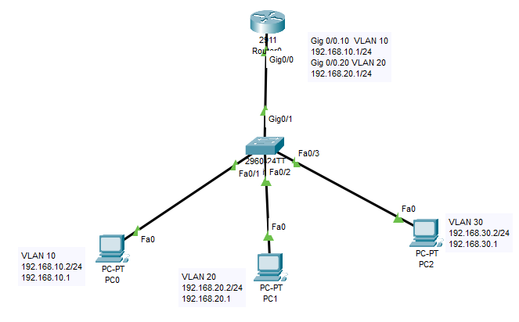

1. Assigning the IP Addresses, to PCs

2. Configure within the switch.

a. VLAN

b. Assign the specified interfaces to the specific VLANs

c. Define Access Ports and Trunk Ports

3. Configure router with dotlQ encapsulation by making each of sub-interfaces

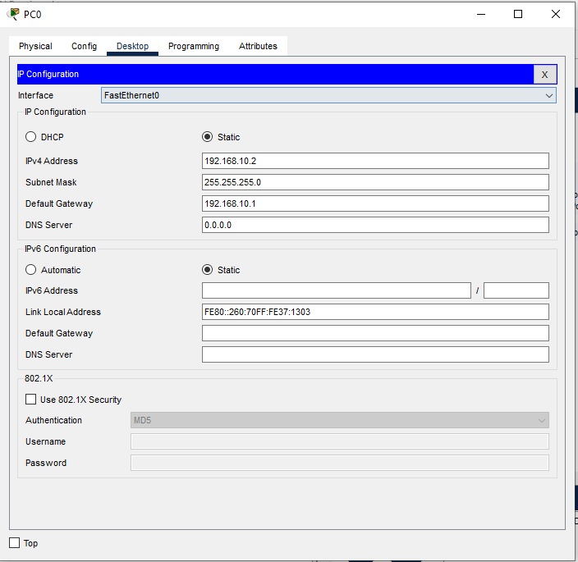

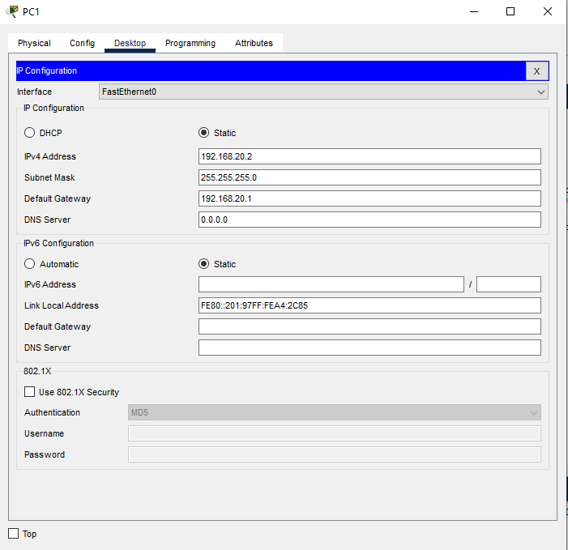

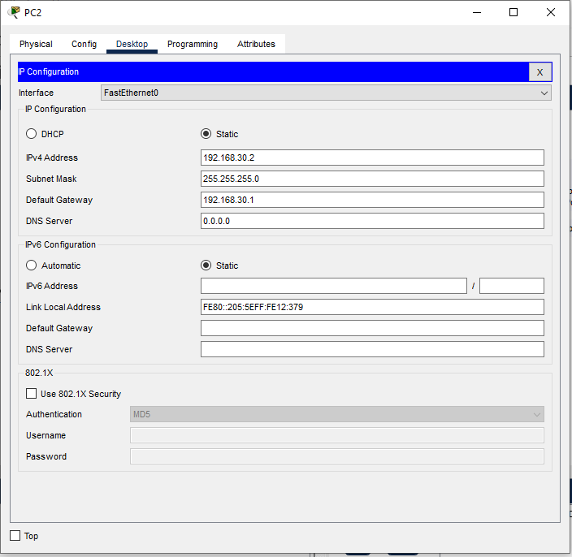

Switch>

Switch>en

Switch$conf t

Switch(config)#VLAN 10

Switch(config-vlan)#exit

Switch(config)#VLAN 20

Switch(config-vlan)#exit

Switch(config)#VLAN 30

Switch(config-vlan)#exit

Switch(config)#

Switch(config)#exit

Switch#

Switch#show vlan brief

VLAN Name Status Ports

---- -------------------------------- --------- -------------------------------

1 default active Fa0/4, Fa0/5, Fa0/6, Fa0/7

Fa0/8, Fa0/9, Fa0/10, Fa0/11

Fa0/12, Fa0/13, Fa0/14, Fa0/15

Fa0/16, Fa0/17, Fa0/18, Fa0/19

Fa0/20, Fa0/21, Fa0/22, Fa0/23

Fa0/24, Gig0/2

10 VLAN0010 active Fa0/1

20 VLAN0020 active Fa0/2

30 VLAN0030 active Fa0/3

1002 fddi-default active

1003 token-ring-default active

1004 fddinet-default active

1005 trnet-default active

Switch#

Switch#conf t

Enter configuration commands, one per line. End with CNTL/Z.

Switch(config)#int fa 0/1

Switch(config-if)#switchport access VLAN 10

Switch(config-if)#switchport mode access

Switch(config-if)#exit

Switch(config)#int fa 0/2

Switch(config-if)#switchport access VLAN 20

Switch(config-if)#switchport mode access

Switch(config-if)#exit

Switch(config)#int fa 0/3

Switch(config-if)#switchport access VLAN 30

Switch(config-if)#switchport mode access

Switch(config-if)#exit

Switch(config)#exit

Switch#

%SYS-5-CONFIG_I: Configured from console by console

Switch#show vlan brief

VLAN Name Status Ports

---- -------------------------------- --------- -------------------------------

1 default active Fa0/4, Fa0/5, Fa0/6, Fa0/7

Fa0/8, Fa0/9, Fa0/10, Fa0/11

Fa0/12, Fa0/13, Fa0/14, Fa0/15

Fa0/16, Fa0/17, Fa0/18, Fa0/19

Fa0/20, Fa0/21, Fa0/22, Fa0/23

Fa0/24, Gig0/2

10 VLAN0010 active Fa0/1

20 VLAN0020 active Fa0/2

30 VLAN0030 active Fa0/3

1002 fddi-default active

1003 token-ring-default active

1004 fddinet-default active

1005 trnet-default active

Switch#conf t

Switch#show run

Building configuration...

Current configuration : 1256 bytes

!

version 12.2

no service timestamps log datetime msec

no service timestamps debug datetime msec

no service password-encryption

!

hostname Switch

!

!

!

!

!

!

spanning-tree mode pvst

spanning-tree extend system-id

!

interface FastEthernet0/1

switchport access vlan 10

switchport mode access

!

interface FastEthernet0/2

switchport access vlan 20

switchport mode access

!

interface FastEthernet0/3

switchport access vlan 30

switchport mode access

!

interface FastEthernet0/4

!

interface FastEthernet0/5

!

interface FastEthernet0/6

!

interface FastEthernet0/7

!

interface FastEthernet0/8

!

interface FastEthernet0/9

!

interface FastEthernet0/10

!

interface FastEthernet0/11

!

interface FastEthernet0/12

!

interface FastEthernet0/13

!

interface FastEthernet0/14

!

interface FastEthernet0/15

!

interface FastEthernet0/16

!

interface FastEthernet0/17

!

interface FastEthernet0/18

!

interface FastEthernet0/19

!

interface FastEthernet0/20

!

interface FastEthernet0/21

!

interface FastEthernet0/22

!

interface FastEthernet0/23

!

interface FastEthernet0/24

!

interface GigabitEthernet0/1

switchport mode trunk

!

interface GigabitEthernet0/2

!

interface Vlan1

no ip address

shutdown

!

!

!

!

line con 0

!

line vty 0 4

login

line vty 5 15

login

Switch#copy running-config startup-config

Destination filename [startup-config]?

Building configuration...

[OK]

Switch#

Switch#

Router>en

Router#conf t

Enter configuration commands, one per line. End with CNTL/Z.

Router(config)#interface gigabitethernet 0/0.10

Router(config-subif)#

%LINK-5-CHANGED: Interface GigabitEthernet0/0.10, changed state to up

%LINEPROTO-5-UPDOWN: Line protocol on Interface GigabitEthernet0/0.10, changed state to up

Router(config-subif)#enc

Router(config-subif)#encapsulation d

Router(config-subif)#encapsulation dot1Q 10

Router(config-subif)#ip address 192.168.10.1 255.255.255.0

Router(config-subif)#exit

Router(config)#

Router(config)#interface gigabitethernet 0/0.20

Router(config-subif)#

%LINK-5-CHANGED: Interface GigabitEthernet0/0.20, changed state to up

%LINEPROTO-5-UPDOWN: Line protocol on Interface GigabitEthernet0/0.20, changed state to up

Router(config-subif)#encapsulation dot1Q 20

Router(config-subif)#ip address 192.168.20.1 255.255.255.0

Router(config-subif)#exit

Router(config)#interface gigabitethernet 0/0.30

Router(config-subif)#

%LINK-5-CHANGED: Interface GigabitEthernet0/0.30, changed state to up

%LINEPROTO-5-UPDOWN: Line protocol on Interface GigabitEthernet0/0.30, changed state to up

Router(config-subif)#encapsulation dot1Q 30

Router(config-subif)#ip address 192.168.30.1 255.255.255.0

Router(config-subif)#exit

Router(config)#exit

Router#

%SYS-5-CONFIG_I: Configured from console by console

Router#show ip route

Codes: L - local, C - connected, S - static, R - RIP, M - mobile, B - BGP

D - EIGRP, EX - EIGRP external, O - OSPF, IA - OSPF inter area

N1 - OSPF NSSA external type 1, N2 - OSPF NSSA external type 2

E1 - OSPF external type 1, E2 - OSPF external type 2, E - EGP

i - IS-IS, L1 - IS-IS level-1, L2 - IS-IS level-2, ia - IS-IS inter area

* - candidate default, U - per-user static route, o - ODR

P - periodic downloaded static route

Gateway of last resort is not set

192.168.10.0/24 is variably subnetted, 2 subnets, 2 masks

C 192.168.10.0/24 is directly connected, GigabitEthernet0/0.10

L 192.168.10.1/32 is directly connected, GigabitEthernet0/0.10

192.168.20.0/24 is variably subnetted, 2 subnets, 2 masks

C 192.168.20.0/24 is directly connected, GigabitEthernet0/0.20

L 192.168.20.1/32 is directly connected, GigabitEthernet0/0.20

192.168.30.0/24 is variably subnetted, 2 subnets, 2 masks

C 192.168.30.0/24 is directly connected, GigabitEthernet0/0.30

L 192.168.30.1/32 is directly connected, GigabitEthernet0/0.30

Router#

Router#